Low Level Design
On
Retail Autonomous Researcher Agent

Course Name: Agentic AI

Institution Name: Medicaps University – Datagami Skill Based Course

Student Name(s) & Enrolment Number(s):
Sr no | Student Name | Enrolment Number
1. | ADITYA KULKARNI | EN22CS301052
2. | ABHISHEK GURJAR | EN22CS301038
3. | AKSHAT DUBEY | EN22CS301089
4. | ADITYA TIWARI | EN22CS301071
5. | AKSHAY PRATAP SINGH | EN22CS301097

Group Name: A1
Project Number: AAI-01
Industry Mentor Name:
University Mentor Name: Prof. Nishant Shrivastava
Academic Year: 2026

Table of Contents

Introduction
1.1 Purpose
1.2 Scope
Detailed System Design
2.1 Module Design (Agents, Tools, Tasks)
2.2 flow chart
2.3 Architecture Design
2.4 Data Flow

Conclusion

Introduction

1.1 Purpose
The purpose of the Low Level Design (LLD) for the Retail Autonomous Researcher Agent is to provide a detailed technical description of the system components, internal modules, and their interactions. It explains how each part of the system works together to collect, process, analyze, and generate insights from retail data automatically.

The LLD focuses on the internal architecture of the system including data flow, algorithms, APIs, and module-level implementation. It helps developers understand how the autonomous agent operates, how data is processed, and how results are generated for the end user.

1.2 Scope

The scope of the Low Level Design for the Retail Autonomous Researcher Agent includes the following technical components:

- Data Collection Module
Responsible for collecting retail data from multiple sources such as e-commerce platforms, APIs, and web scraping tools.

- Data Processing Module
Cleans, filters, and structures the collected data to make it suitable for analysis.

- Analysis Engine
Uses machine learning and AI algorithms to analyze trends, customer sentiment, product demand, and competitor pricing.

- Knowledge Storage / Database Layer
Stores collected data, processed information, and generated insights in databases for further use.

- Autonomous Decision Agent
Controls the workflow of the system by deciding when to collect data, analyze it,
and generate reports.

Detailed System Design

2.1 Module Design (Agents, Tools, Tasks)

Overview
The system is divided into three main agent :
- Agents : Planner Agent, Research Agent, Tool Agents (Web Scraper, SERP), Synthesizer, Formatter, Knowledge Manager.
- Planner Agent: Receives user query, breaks into sub-tasks, assigns tasks to specialized agents via CrewAI. Handles retries and failure policies.
- Research Agent: Executes search strategies (broad web, news, journals), prioritizes sources, and extracts candidate passages with source metadata.

2.2 flow chart

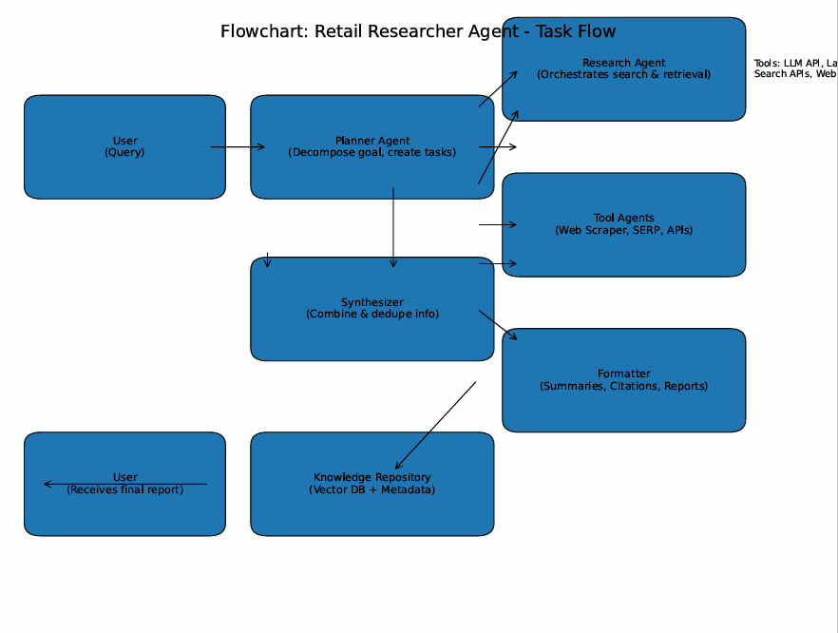
2.3 Application Design

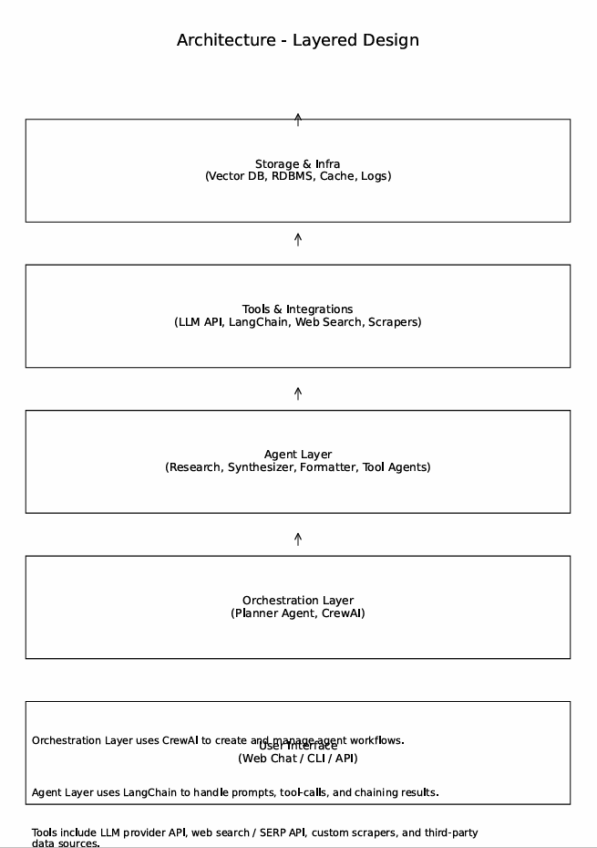

Tools include LLM provider API, web search / SERP API, custom scrapers, and third-party data sources. Tools include LLM provider API, web search / SERP API, custom scrapers, and third-party data sources.

2.4 Data Flow
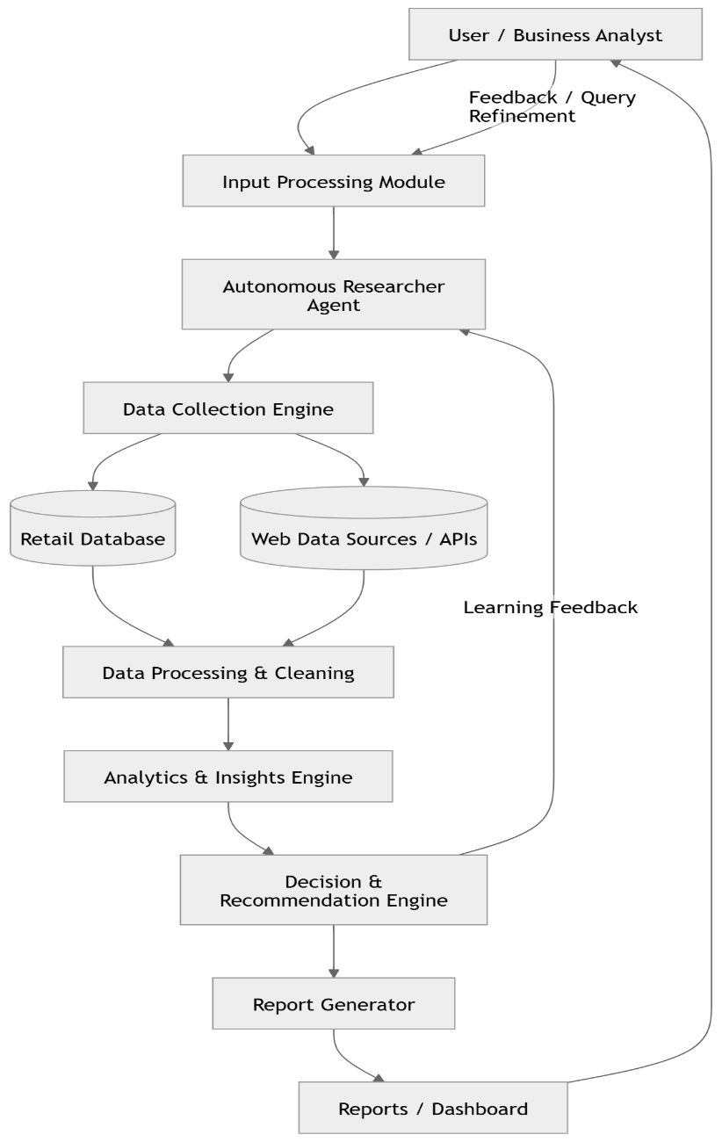

Conclusion

The Retail Autonomous Researcher Agent provides an intelligent and automated solution for conducting retail market research. The system collects data from multiple sources such as e-commerce platforms, customer reviews, and market databases, and processes this information using advanced technologies like Artificial Intelligence, Machine Learning, and Natural Language Processing. By automating the research process, the system reduces manual effort and improves the speed and accuracy of data analysis.

Through different modules such as data collection, data processing, analysis, and report generation, the agent is able to identify market trends, analyze competitor strategies, and understand customer preferences. This helps retailers make data-driven decisions related to pricing, inventory management, and marketing strategies.

In conclusion, the Retail Autonomous Researcher Agent enhances the efficiency of retail research by providing real-time insights and automated analysis, allowing businesses to respond quickly to market changes and maintain a competitive advantage. Future improvements may include integrating more data sources, improving AI models, and adding predictive analytics for better decision support.

